# Practical2_List
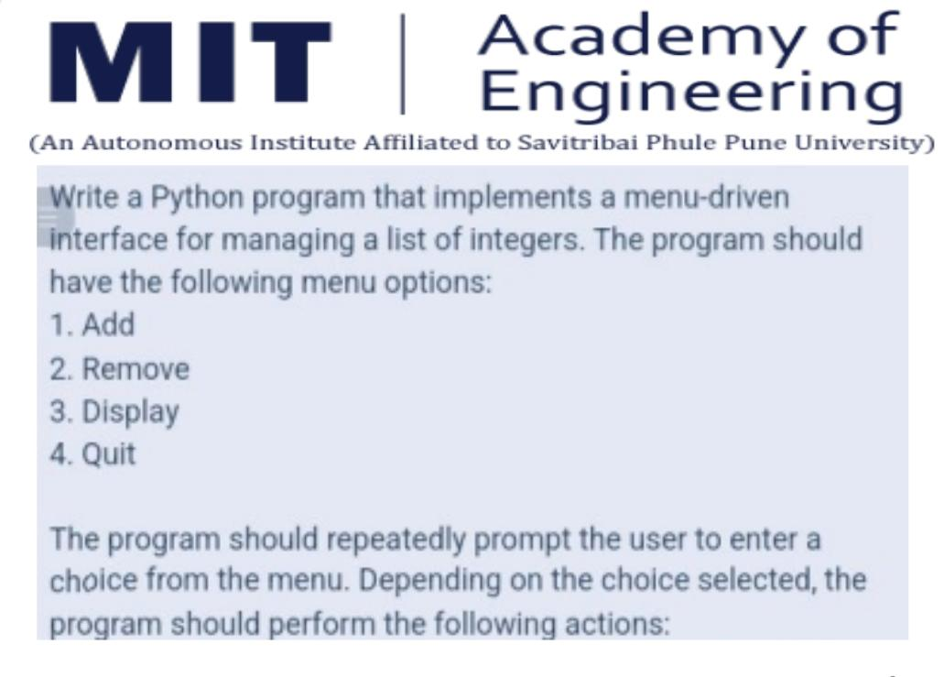
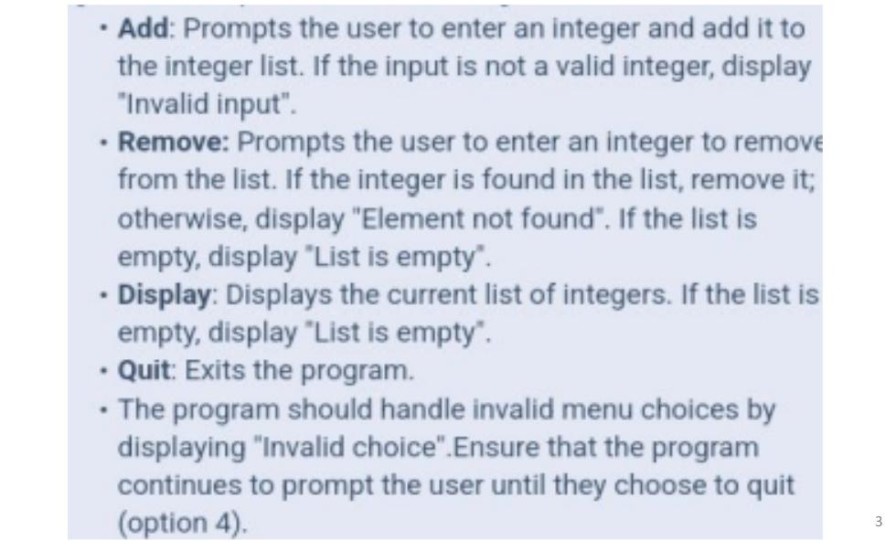

Code:
# List operations
Numbers = []

while True:
print("-----Menu-----")
print("1. Add")
print("2. Remove")
print("3. Display")
print("4. Quit")

choice = int(input("Enter your choice (1-4) : "))

if(choice == 1):
num = int(input("Enter an integer to add : "))
Numbers.append(num)
print("Added Successfully!")

elif(choice == 2):
if not Numbers:
print("List is empty!")
else:
num = int(input("Enter an integer to add : "))
if num in Numbers:
Numbers.remove(num)
print("Removed Successfully!")
else:
print("Element not found!")

elif(choice == 3):
print("Current list :")
print(Numbers)

elif(choice == 4):
print("Exiting program...")
break

else:
print("Invalid Choice!")

Output:
